|  |  |  |
| --- | --- | --- |
| **MODULE:** 11 | **LESSON:** 2 | ADDITION AND SUBTRACTION EQUATIONS |

The goal when solving equations that contain a variable is **toget the variable by itself on one side of the equation.**

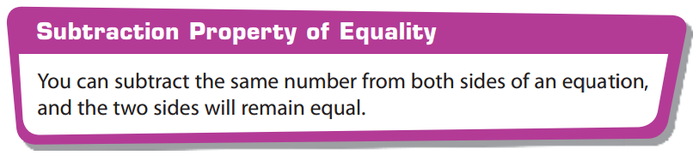

**Step 1:** Move the number that is on the same side of the equation as the variable to the other side of the equation.

**Step 2:** Do the ***INVERSE OPERATION***

